EER Description:

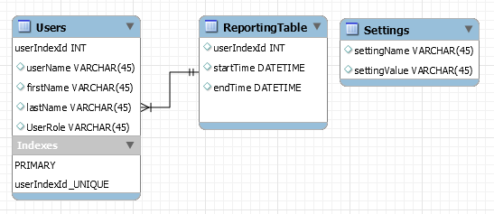

Users:
The Users table will hold all of the user information such as their unique user id along with, user name, first name, last name and their role in the database.
ReportingTable:
The Reporting table with hold all of the clock in and out times of a user and will identify the user from their user id that is given and linked to them from the users table.
Settings:
This table will contain setting variables that we can use to check if a user knows a password or other key settings that may be implemented for the future. One possible setting could be used to trigger an even that would clear out a database of all inserts.

